**DAILY ONLINE ACTIVITIES SUMMARY**

|  |  |  |  |  |  |  |  |  |
| --- | --- | --- | --- | --- | --- | --- | --- | --- |
| **Date:** | **17/6/2020** | | | | | **Name:** | **Banish M G** | |
| **Sem & Sec** | **8th Sem** | | | | | **USN:** | **4AL16CS20** | |
| **Online Test Summary** | | | | | | | | |
| **Subject** | | **--------** | | | | | | |
| **Max. Marks** | | **------** | | **Score** | | | **-------** | |
| **Certification Course Summary** | | | | | | | | |
| **Course** | **Python for data science** | | | | | | | |
| **Certificate Provider** | | | **udemy** | | **Duration** | | | **23hrs** |
| **Coding Challenges** | | | | | | | | |
| **Problem Statement:**  Python program to check if a binary tree is bst or not. | | | | | | | | |
| **Status:COMPLETED** | | | | | | | | |
| **Uploaded the report in Github** | | | | | **yes** | | | |
| **If yes Repository name** | | | | | **Banish_MG** | | | |
| **Uploaded the report in slack** | | | | | **yes** | | | |

Online Test Details: (Attach the snapshot and briefly write the report for the same)

Certification Course Details: (Attach the snapshot and briefly write the report for the same)

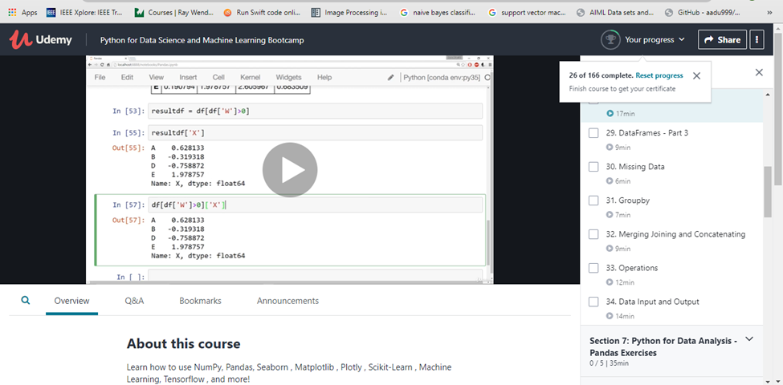

Coding Challenges Details: (Attach the snapshot and briefly write the report for the same)

Python program to check if a binary tree is bst or not.

INT_MAX=4294967296

INT_MIN=-4294967296

classNode:

def__init__(self,data):

self.data=data

self.left=None

self.right=None

def isBST(node):

return(isBSTUtil(node,INT_MIN,INT_MAX))

def isBSTUtil(node,mini,maxi):

if node is None:

return True

if node.data<miniornode.data>maxi:

return False

return(isBSTUtil(node.left,mini,node.data-

1)andisBSTUtil(node.right,node.data+1,maxi))

root=Node(4)

root.left=Node(2)

root.right=Node(5)

root.left.left=Node(1)

root.left.right=Node(3)

if(isBST(root)):

print("isBST")

else:

print("Not a BST")